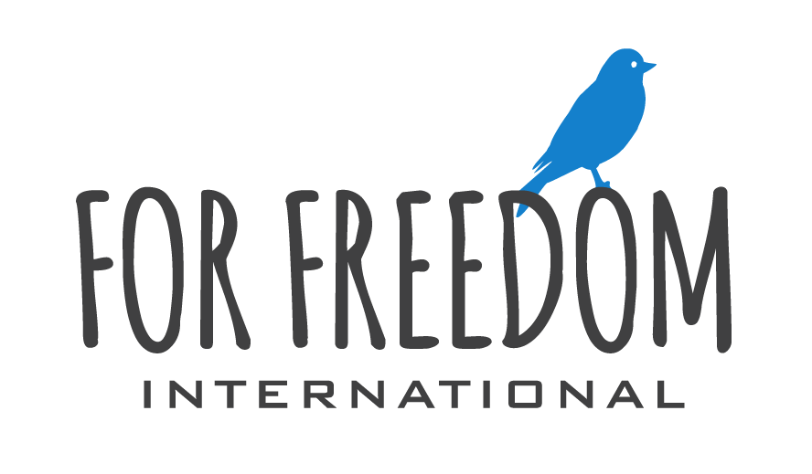

Marketing & Partner Relations Director

Full Time Volunteer Position – Self Funded
(Budget and Donations processed through FFI USA or Canadian Charities)

We are looking for someone to help organize, create, and implement our communication strategies. This would include helping to create content and images for blog posts and helping to create an editorial calendar for content delivery through our blog, social media platforms, and Mailchimp general newsletter. This person would also help us develop and launch yearly fundraising campaigns.
This is a full-time volunteer position based in Phuket Thailand.

This is you:
We are looking for an enthusiastic team member to manage our external and internal communications. You will promote a positive public image and control the dissemination of information on our organizations behalf. You are passionate about meaningful communication, technology, systems, organized and can meet deadlines. You enjoy the task of educating and challenging people through the written or visual media. You think stories are one of the most powerful communication mediums available to any organization.
Experience in corporate communications and project management are important qualities but are not a pre-requisite. Your enthusiasm and positive attitude will help you gain the trust of colleagues and external parties alike.

ESSENTIAL DUTIES AND RESPONSIBILITIES: (i.e. those which are basic, necessary, and an integral part of the job, are indicated below.)
Behavior:
- Maintains a personal relationship with Jesus Christ and is a consistent witness of Jesus Christ.
- Will meet monthly with a spiritual mentor and accountability person.
- Speaks of For Freedom International, our staff, our partners, participants in our programs, and other organizations with respect and honor across all communication platforms, faithfully praying for each.
- Acts as an Advocate for FFI and each individual FFI serves, understanding the problem, raising awareness of the need and how everyone can respond.
- Adheres to the Mission, Vision, Values and Statement of Faith of the C&MA of Canada
- While some behavior and social conduct is acceptable in general culture, activities that contradict Scripture, even if accepted by society, will not be allowed.
- Agrees and accepts to the employee handbook and the hiring process which includes accepting the Child Protection Policy and also providing a police criminal check.
- Other duties as assigned.

Purpose of Job Assignment:
- Developing effective corporate communication strategies.
- Systems Development (with a focus on automation)
  - Create and manage social media platforms
    - FB, Instagram, LineApp, etc.
  - Automation funnels through Mailchimp and other platforms
- Management of partner and donor relations:
  - Producing Annual and quarterly updates
  - Foster relationships with advocates, key influencers and donors. (This will include both secular and faith based partners and donors)
- Content Creation
  - Drafting content (e.g. press releases) for mass media or company website.
  - Help organize marketing events (golf tournament, marathon, etc. – FFI has never done this before but is interested in helping build local awareness.)
  - Collaborate with marketing and design professionals to produce published content.
  - Handle requests for interviews, statements etc.
  - Managing internal communications (memos, newsletters etc.)
- Assist in communication of strategies or messages from senior leadership.

Skills and Experience
- Has a proven track record of being an active learner and problem solver.
- Experience working with multiple stakeholders. (Donors, external partners, vendors, etc.)
- Graphic Design experience a strong asset.
- You are a natural systems thinker. You can visualize a communication funnel and the ability to create or learn how to create such systems (Example – MailChimp automation sequences).
- You are great with people. You build trust and rapport quickly.
- You have a proven track record of meeting deadlines
- You are goal oriented (FFI uses quarterly objectives and key results. OKR’s).

Key financial accountabilities:
- Fundraise for 100% of Living and Ministry Expenses
Leadership:
- Contribute to a high-performance focused learning environment through personal leadership, teamwork and accountability.
- Foster and support a positive work culture where employee input is encouraged and differences are resolved biblically.

Team Contribution:
- Support policy wide decisions.
- Attend all staff meetings.
- Participate in all planning sessions, reporting, performance evaluation expectations and any other staff related items.
- Attend Team Prayer Meetings.

Security:
- Ensure that safety and security of team members and FFI information, documents, strategies are kept in the strictest of confidence.
- All FFI strategies are considered confidential unless otherwise noted in formal FFI documentation

POSITION QUALIFICATIONS & REQUIREMENTS:
Key Relationships
Reports to: Director of Operations
Direct Reports: TBD
Start Date: TBD
End Date: TBD

Skills and Attributes
Specific and General skills and abilities required to meet the expectations of the position.
- Must be flexible to jump in where its needed (even outside the stated job assignment) for the empowerment and functionality of the team in lack of workers.
- Strives for performance and excellence in their work and the teams work.
- Team oriented while being organized, efficient and focused.
- Patient and works well under stress.
- Positive attitude.
- A passion to train people both vocationally, and spiritually.
- Able to achieve goals in a cross-cultural team.
- Supports and helps teammates.
- Professional in all written and spoken communication.
- Strong customer service attitude and work ethic.
- Willingly accepts responsibility.
- Takes initiative.
- Ability to work by themselves yet simultaneously keeping their teammates informed.
- A passion for reaching people for Christ on a global scale.

Position Requirements
- Sign and complete all required documents as part of the application process.
- 100% Self-funded for living and ministry expenses
- Abide by FFI Staff Handbook and Community Life Statements

Physical Demands, Work Environment & Conduct.
The physical demands and work environment characteristics are representative of those that must be met by a volunteer to successfully perform the essential functions of this job. Reasonable accommodations may be made to enable individuals with disabilities to perform the essential functions.

Physical:
-Must be able to travel long distances via plane, automobile, moto, bicycle and walking.
-Must be able to climb stairs during the course of a normal day serving.

Position Disclosure Statement
The above statements and description are intended to describe the nature and level of work being performed within this position. They are not intended to be an exhaustive list of all responsibilities, duties, and tasks. Other similar or additional duties are to be performed as assigned. You, or FFI, may terminate the position at any time for any reason.

_______________________________________________
Name (Print)

_______________________________________________ ___________________
Signature Date

