For Freedom International – Start Your Giving Group

Introduction

- For Freedom International has partnered with Chimp.net to manage our online donations and campaign creation for our donors.
- Giving Groups are ways that you can create unique donation pages to share with your friends and family in order to raise donations for For Freedom International.
- All donations are fully tax deductible and will be receipted by Chimp.
- All funds will be sent directly to the head office of the Christian and Missionary Alliance Canada. Donations will be used to fund the ministry work of Darren and Naomi Herbold in Thailand.

Below are some instructions and links to useful help documents on getting started and managing a Giving Group. People can also reach out to hello@chimp.net if they have any questions.
NOTE: It’s recommended that you use a desktop and not a mobile device when getting set up or making changes to your Giving Group.

Step #1 - Getting started
You can easily start a Giving Group (fundraising page) for For Freedom International here. If you don’t have a personal Chimp Account, you will need to sign up for one as part of the process.
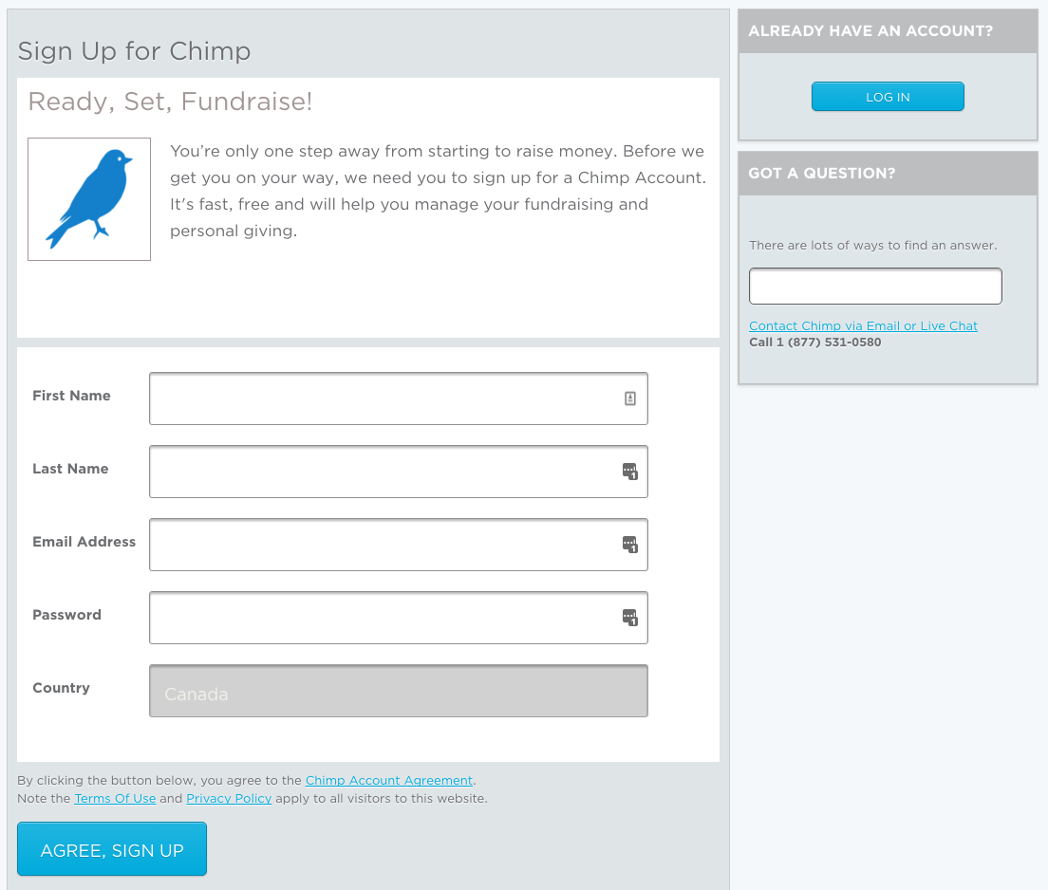

If you sign up for an account, you’ll be asked to verify your email address before you proceed.

Step #2 – Activate Your Account

You’re now ready to start your Giving Group! For Freedom International has already pre-populated some of the information for you. There will be four screens you’ll need to complete, and you’ll find all the different sections to fill out here. 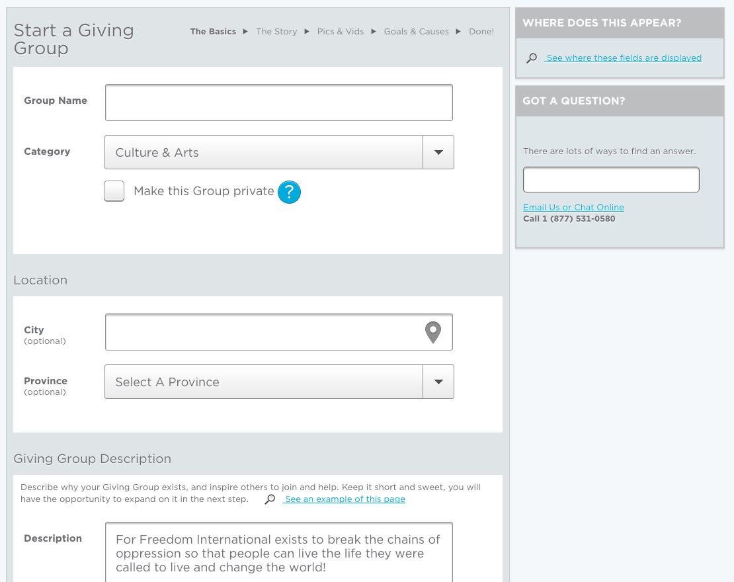

Sharing your Giving Group
You can direct family and friends to your personal Giving Group by including your group’s URL in a personal email. You can find this in your Giving Group under Spread the Word.

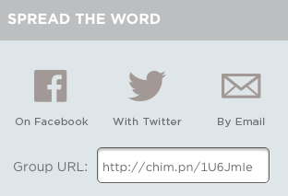

You can also invite people directly to become members of your Giving Group, and you can share your group through social media. Find out how >>

Donations
Anyone who gives to your Giving Group will automatically be issued a tax receipt by Chimp Foundation. You can learn more about tax receipts here.

All donations to your Giving Group will automatically be sent to the For Freedom International campaign. You don’t need to worry about managing donations that come in.

Thanking donors
Once donations start rolling in, you can thank the people who’ve supported you. You can thank them on Chimp by commenting on their donation (if the donor has joined your group as a member) or download donor information in your Giving Group.

